Urban biogeography of fungal endophyte communities in *Metrosideros excelsa* throughout San Francisco

**Introduction and Background**

As of 2014, more than 40% of people in the US live in urban locations (OECD 2014). In recent years, ecologists have begun studying the urban environment just as they would a natural environment, in order to understand the novel environmental conditions this setting presents to the organisms that live there. For example, recent studies have shown that plant life in large cities can impact temperature, air quality, and other aspects of human health (Willis and Petrofsky 2017). In a study spanning the United States, Nowak *et al.* (2014) showed that plant life can take up significant amounts of carbon dioxide from urban air. Kong *et al.* (2014) have shown that healthy plant life can reduce the urban heat island effect in China. Therefore, understanding the impact of urban environments on plant health could help to allow those plants to thrive, benefitting the human inhabitants of the city as well as the environment as a whole.

One potentially major factor influencing plant health that has yet to be studied in an urban environment in great detail is the endophytic microbiome. Endophytes are microbial organisms, generally bacteria and fungi, that live symbiotically inside the leaves of plants. Inoculation experiments have shown that specific species of endophytes can have an impact on their host’s overall health, including factors such as resistance and susceptibility to disease (Busby *et al.* 2016). In the wild, endophytic communities display species diversity comparable to that of any macroscopic community, even among individual trees from the same species (Gazis *et al.* 2011). However, what factors influence this diversity and to what extent is still poorly understood. The urban setting is unique because factors such as rainfall and elevation will be less apparent in a smaller geographic area, but new factors such as proximity to roads and tall buildings may introduce effects of their own. Studies of suburban forests in Japan have indicated that an urban setting has a notable impact on endophytic diversity (Matsumura and Fukuda 2013). However, the full impact of urban environmental factors on endophytic communities has yet to be completely understood.

In this study, we plan to use culturing and barcode gene sequencing to identify the species makeup of endophytic communities in *Metrosideros excelsa* throughout San Francisco to relate environmental factors with fungal community composition. In a related species, *Metrosideros polymorpha*, in Hawaii Zimmerman and Vitousek (2012) showed that the species makeup of fungal endophyte communities can vary greatly with environmental factors such as elevation and rainfall. Other studies have been conducted on *Metrosideros excelsa* itself in its native home of New Zealand, but there have been few studies about the endophytes in this species outside of its native environment or in an urban setting (but see McKenzie *et al.*1999). When completed, the results of this study will demonstrate which species of endophytes are correlated with particular environmental factors, as well as which environmental factors are related to an increase or decrease of endophytic species diversity overall.

**Methods**

We will select sampling sites based on average traffic, elevation, and temperature data from around San Francisco, aiming to represent a variety of urban environmental factors. These data will be obtained from online sources. Variables such as tree size (diameter at breast height and crown height), proximity to the ocean, and proximity to other trees will also be taken into consideration. We will use the Urban Forest Map, which pinpoints the location of every *M. excelsa* individual in the city, to locate focal trees. We will sample from at least 7 different sites, and culture from at least 4 trees from each site. Mature sun leaves will be collected by clipping three branches from different aspects of each tree. After the branches are collected, we will select 6-8 asymptomatic leaves from each tree for fungal isolation.

To isolate fungi into culture, we will first surface-sterilize the leaves by rinsing them in 95% ethanol for 10 seconds, then 10% bleach for 2 minutes, and then 70% ethanol for 2 minutes (Arnold *et al.* 2003). After allowing them to dry in a sterile flow hood, we will cut them into 2mm squares and place each of 100 tissue pieces (per tree) into a slant tube of 1.5% Malt Extract Agar (MEA) media. After a week, we will subculture the fungi that grew onto 35 mm petri dishes (also MEA). These tubes will continue to be checked on a weekly basis for new growth; this will be subcultured as well.

The cultured fungi will be used for morphotyping, barcode sequencing, and vouchering. We will extract and amplify the nuclear ribosomal Internal Transcribed Spacer (nrITS) region of each fungus using the Sigma Extract-N-Amp PCR kit. Sanger sequencing of this locus will allow us to identify the species based on BLAST searches of the GenBank and UNITE databases. Live fungi will also be vouchered in tubes of sterile distilled water in order to archive them for future studies.

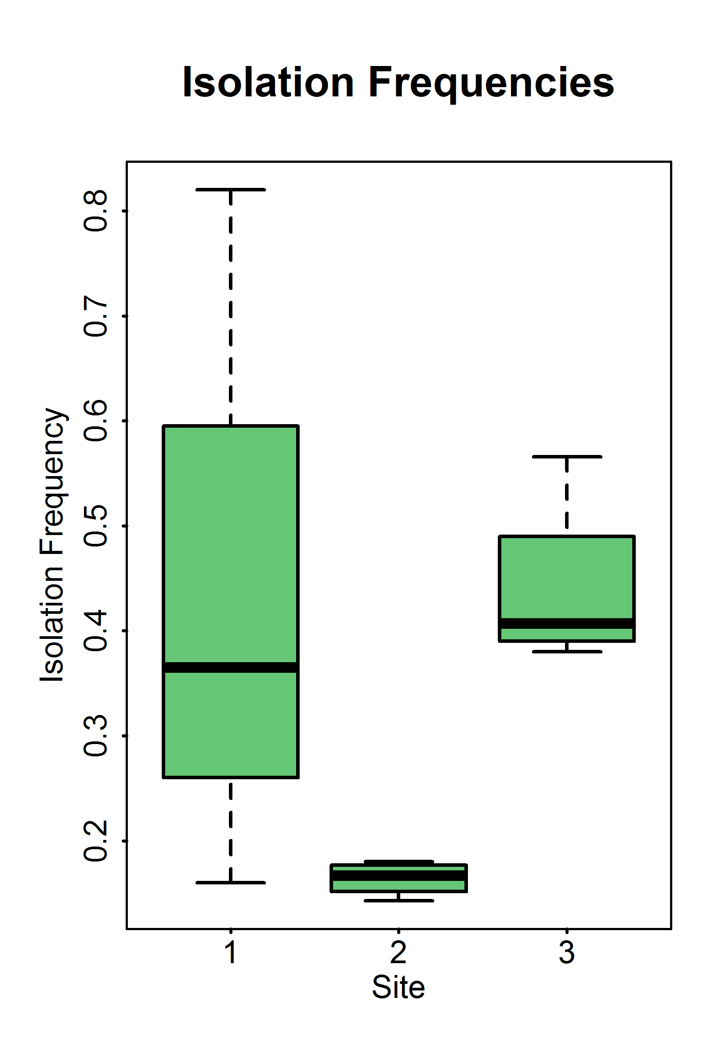**Figure 1.** Fungal isolation frequencies from asymptomatic sun leaves of *Metrosideros excelsa*. Site 1 was at Balboa St. and 27th Ave. Site 2, the downtown site, was at Montgomery St. and Washington St. Site 3 was at Burlwood Dr. and Los Palmos Dr.

**Expected Results and Significance**

Earlier this year, we conducted preliminary research using the methods above at three sites. We found a lower isolation frequency in the downtown site (Figure 1) than in the other two sites (Kruskal-Wallis p < 0.5). Based on this result, we expect to see a lower isolation frequency for fungal endophytes cultured from more urban sites. We will focus on doing additional sampling in these sites in order to determine if our preliminary data is indicative of a pattern or simply an anomaly. We will also try to sample from sites that differ from the downtown sites in only one variable, such as sites with similar traffic levels but a lower temperature. We expect that the best predictor of endophytic diversity will be either traffic levels or proximity to other trees, because high traffic likely lowers the local air quality, and neighboring plants could potentially expose the studied trees to a greater diversity of endophytic fungal propagules. As endophytes can have a significant impact on overall plant health (Busby *et al.* 2016), understanding the biogeography of the endophytic microbiome in urban trees is thus a critical step towards sustainable management of tree health in urban environments.

**Sources Cited**

Arnold, A. E., L. C. Mejia, D. A. Kyllo, E. I. Rojas, Z. Maynard, N. Robbins, and E. A. Herre. 2003. Fungal endophytes limit pathogen damage in a tropical tree. Proceedings of the National Academy of Sciences 100:15649-15654.

Busby, P.E., Ridout, M. & Newcombe, G. Plant Mol Biol. 2016. Fungal endophytes: modifiers of plant disease. 90: 645. 10.1007/s11103-015-0412-0.

Gazis, R., Rehner, S. and Chaverri, P. 2011. Species delimitation in fungal endophyte diversity studies and its implications in ecological and biogeographic inferences. Molecular Ecology, 20:14 p 3001–3013.

Kong, F., Yin, H., James, P., Hutyra, L. R., and He, H. S. 2014. Effects of spatial pattern of greenspace on urban cooling in a large metropolitan area of eastern China. Landscape and Urban Plan. 128, 35 (2014).

Johnston, P. R., P. W. Sutherland, and S. Joshee. 2006. Visualising endophytic fungi within leaves by detection of (1⟶3)-ß-D-glucans in fungal cell walls. Mycologist 20:159-162.

Matsumura, E. and Fukuda, K. 2013. A comparison of fungal endophytic community diversity in tree leaves of rural and urban temperate forests of Kanto district, eastern Japan. Fungal Biology 117:3 p 191-201.

McKenzie, E. H. C., Buchanan, P. K., Johnston, P.R. 1999. Fungi on pohutukawa and other Metrosideros species in New Zealand. New Zealand Journal of Botany 37:335-354.

Nowak D. J., Hirabayashi S., Bodine A., and Greenfield E. 2014. Tree and forest effects on air quality and human health in the United States. Environmental Pollution 193:119-129

OECD (2017), National population distribution (indicator). doi: 10.1787/7314f74f-en

Willis, K. J. and Petrofsky, G. 2017. The natural capital of city trees. Science 356:6336 p 374-376.

Zimmerman, N.B., and Vitousek, P.M. 2012. Fungal endophyte communities reflect environmental structuring across a Hawaiian landscape. PNAS, 109: 32 p 13022-13027.